TASK | Used in welding operations
LOCATION OF USE | Factory |  | Assessment  No 031
PRODUCT NAME | Oxygen, compressed
DESCRIPTION OF SUBSTANCE | Colourless, odourless gas
MANUFACTURER | BOC
MANUFACTURERS CONTACT | BOC  Priestley Road,  Worsley  Manchester  M28 2UT  Telephone: 0800 111 333  E-mail: ReachSDS@boc.com
ASSESSOR | Martin Monaghan CMIOSH |  | Date |  | 04 12 25
TITLE | Health and Safety Consultant |  | Review by |  | 04 12 27
Personnel Performing Task  (Please list below) |  | Time Spent  (Minutes/day) | Training Given 
15mins/
day

MSDS Revision Date | Hazard Statement
27 04 2021

Assessment to be conducted in Association with Hazard Data Sheets, a full current copy of which must be attached to this assessment.

Please denote the hazardous properties of the substances used in the task with a 

NEW INTERNATIONAL GLOBALLY HARMONISED HAZARD SYMBOLS
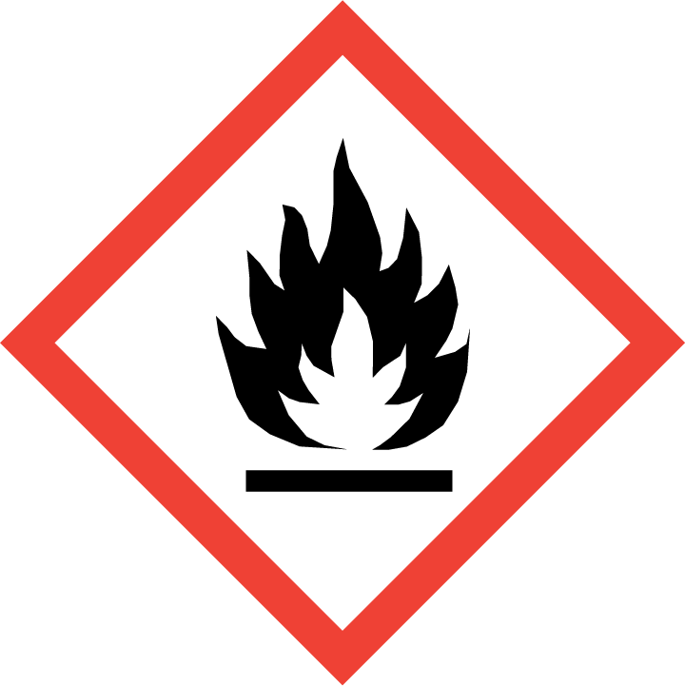 | 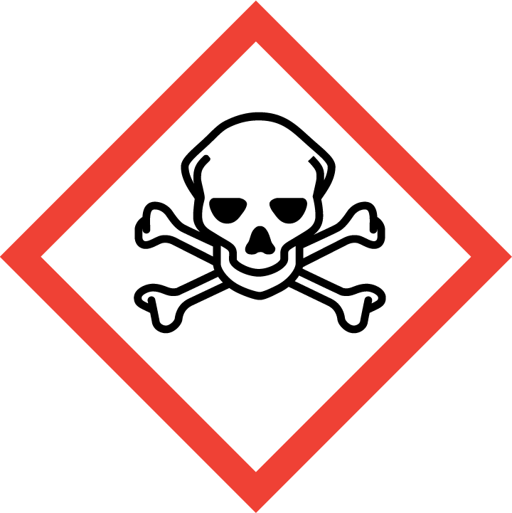 | 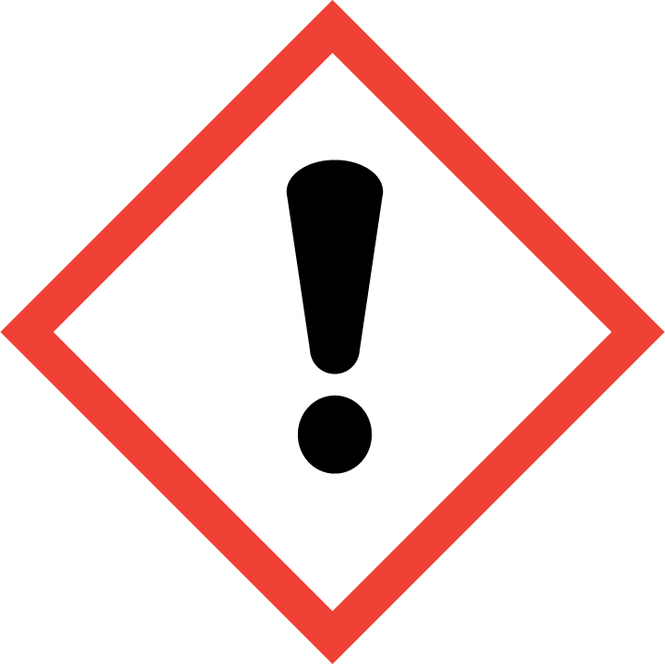 | 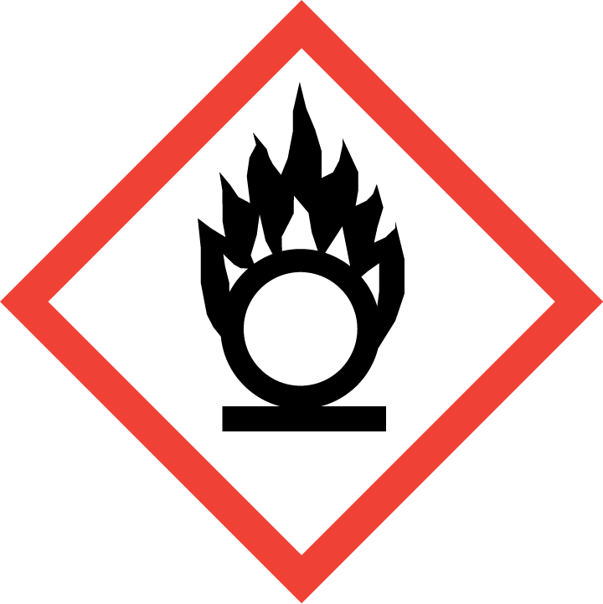 | 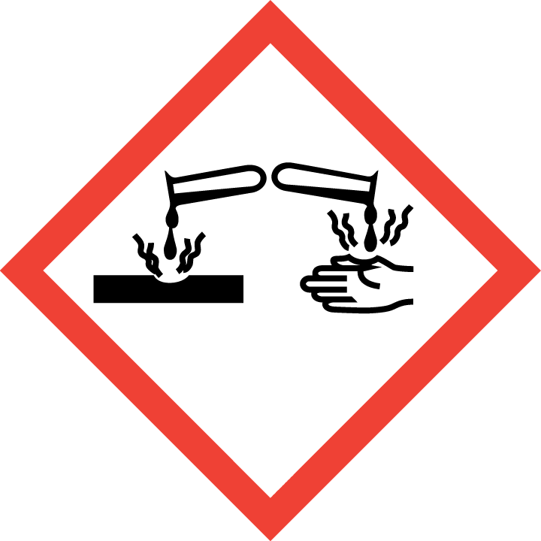 | 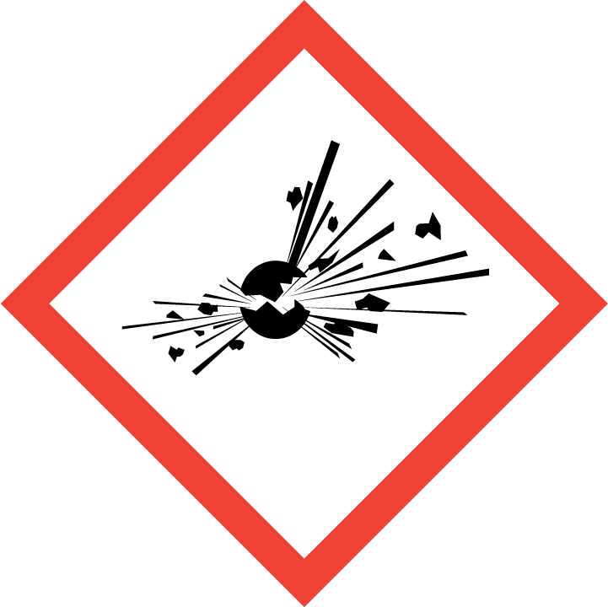 | 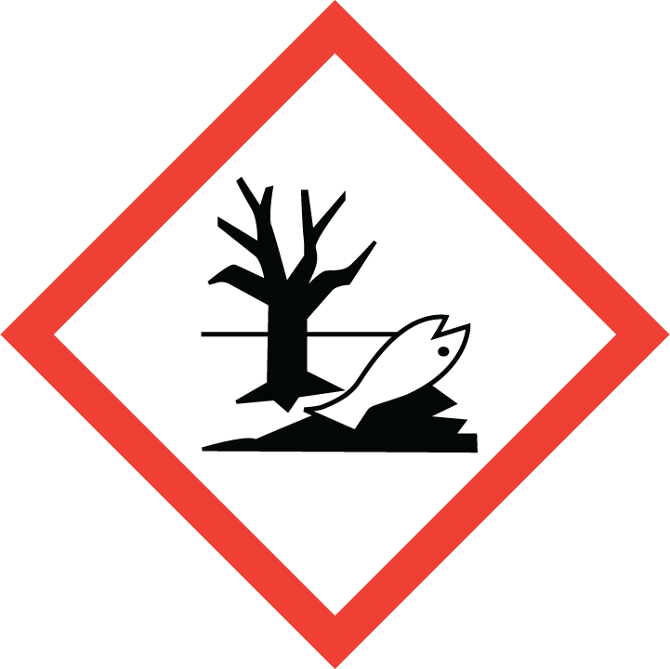 | 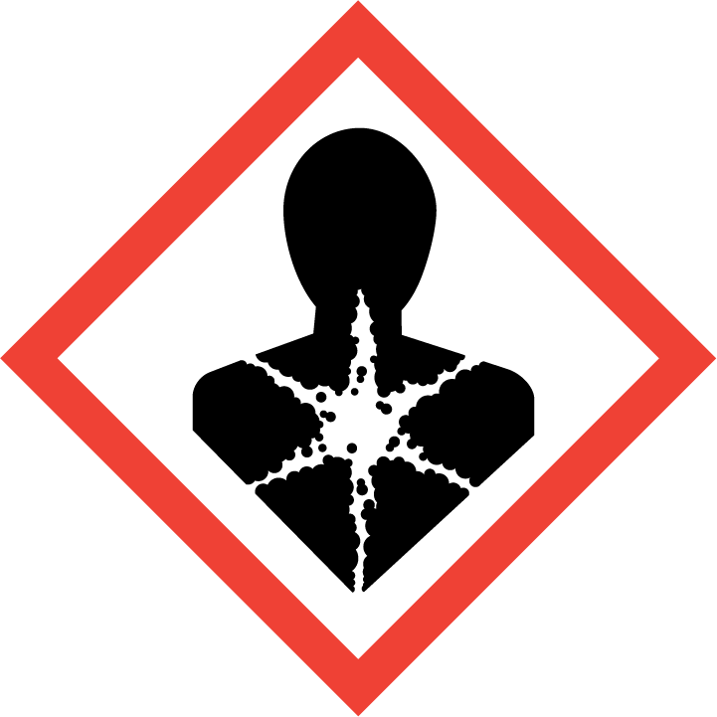
Flammable | Toxic | Harmful | Oxidising | Corrosive | Explosive | Harmful to the environment | Health Hazards i.e., respiratory sensitisation or carcinogenicity


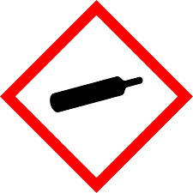
Warning


SMOKING, EATING AND DRINKING ARE PROHIBITED IN THE WORK AREAS.
Information, Instruction and Training must be provided to all users. Young Persons, New or Expectant Mothers and other vulnerable groups must not use or be exposed to this product.

WORKPLACE EXPOSURE LIMITS (WEL’s)
None of the components have assigned exposure limits.

ROUTE OF EXPOSURE
Skin |  | Eyes |  | Inhalation | 
Ingestion |  | Cuts/abrasions |  | Systemic

PERSONS AT RISK
User of product |  | Co workers |  | Members of the public

ROUTE OF EXPOSURE |   FIRST AID MEASURES
Eyes | Adverse effects not expected from this product
Skin | Adverse effects not expected from this product.
Inhalation | Move the exposed person to fresh air at once.
Ingestion | Ingestion is not considered a potential route of exposure
In all cases of doubt, or if symptoms persist seek medical attention. Never give anything by mouth to an unconscious person. If unconscious, place in recovery position and seek medical advice.

PERSONAL PROTECTIVE EQUIPMENT
 |  |  | 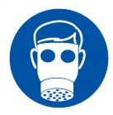 |  | 
YES/NO | YES/NO | YES/NO | YES/NO | YES/NO | YES/NO
 |  |  |  |  | 

HANDLING | STORAGE | TRANSPORT | DISPOSAL
Refer to supplier's handling instructions. Use only properly specified equipment which is suitable for this product, its supply pressure and temperature. Keep equipment free from oil and grease. Open valve slowly to avoid pressure shock. Use only oxygen approved lubricants and sealants. Use only with equipment cleaned for oxygen service and rated for the pressure. ; Do not drag, roll, slide or drop. Do not remove or deface labels provided by the supplier for the identification of the  container contents. When moving containers, even for short distances, use  appropriate equipment e.g., trolley, hand truck, fork truck etc. Secure cylinders in  an upright position at all times, close all valves when not in use. Keep container below 50°C in a well-ventilated place. | Containers should not be stored in conditions likely to encourage corrosion. Stored  containers should be periodically checked for general conditions and leakage.  Container valve guards or caps should be in place. Store containers in location free  from fire risk and away from sources of heat and ignition. Keep away from combustible material. Avoid asphalted locations for storage, transfer, and use  (ignition risk if spilt). Segregate from flammable gases and other flammable  materials being stored. | Transport Hazard Class: 2  Label(s): 2.2  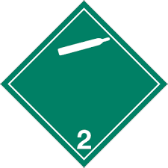 | Do not discharge into any place where its accumulation could be dangerous. Vent  to atmosphere in a well-ventilated place.  Dispose of container via supplier only. Discharge, treatment, or disposal may be subject to national, state, or local laws.

REQUIRED CONTROL MEASURES
- Keep container below 50°C in a well-ventilated place.
- Containers should not be stored in conditions likely to encourage corrosion
- Do not drag, roll, slide or drop container.
- Do not remove or deface labels on container.
- Wear PPE at all times when using / moving product

FIRE PRECAUTIONS
Appropriate Extinguishing Media: Water. Dry powder. Foam. Carbon dioxide
Special hazards arising from the substance or mixture: Supports combustion.
Special protective equipment or firefighters: Firefighters must use standard protective equipment including flame retardant coat, helmet with face shield, gloves, rubber boots, and in enclosed spaces, SCBA. Guideline: EN 469 Protective clothing for firefighters.

ACCIDENTAL RELEASE/SPILLAGE PROCEDURES
Personal precautions . Evacuate area. In case of leakage, eliminate all ignition sources. Provide adequate ventilation. Prevent from entering sewers, basements and work pits, or any place where its accumulation can be dangerous. Monitor the concentration of the released product.
Environmental precautions Prevent further leakage or spillage if safe to do so.
Methods and material for containment and cleaning up Provide adequate ventilation.

MONITORING REQUIREMENTS AND HEALTH SURVEILLANCE

